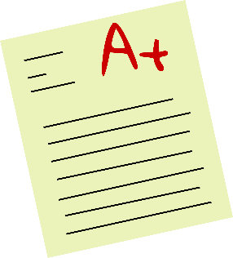
Crash Course MLA
Works Cited (Books and Internet)
Books: if you are using a book in your paper, you will need to cite it at the end of your paper in a Works Cited page. The format for that is as follows:
Last Name, First Name. Title of Book. City of Publication, Publisher, Publication Date.
**All the periods and commas must stay. The book must be italicized.
EXAMPLE: Gleick, James. Chaos: Making a New Science. Penguin, 1987.
Internet Sources: Just like with books, you will need to cite your internet sources at the end of your paper in a Works Cited page. The format for that is as follows:
Editor, author, or compiler name (if available). Name of Site. Version number, Name of
institution/organization affiliated with the site (sponsor or publisher), date of resource creation (if available), URL, DOI or permalink. Date of access (if applicable).
** On internet sources, copy the URL without the http://. You just need www. Also, note how the second and third lines are indented. If a source takes up more than one line, all the lines after the first must be indented once. If the information is not available, substitute the portion with N/A. This goes for both internet and book sources
EXAMPLE:
Felluga, Dino. Guide to Literary and Critical Theory. Purdue U, 28 Nov. 2003,
www.cla.purdue.edu/english/theory/. Accessed 10 May 2006.
Crash Course MLA
In-Text Citations (Books and Internet)
Books: With books, you need to have both the author and page number stated. There are two ways of doing this.
- According to Burkett, “You have the power to do anything as long as you put your heart and soul into it” (281).
** Note: I have stated the author along with the page number. Now, the person reading the paper would be able to look at my Works Cited to find the source. Also note how the period is behind the parentheses.
- “You have the power to do anything as long as you put your heart and soul into it” (Burkett 281).
** Note: there is no comma between the author name and page number.
Although both ways are correct, the first way typically flows better with your paper because you introduced the quote.
Internet Sources: Internet sources follow the same basic two rules as books do.
- In the article “You Do You”, Burkett states “You have the power to do anything as long as you put your heart and soul into it”.
** Note, state both the article name and the author to help your reader understand that this was an internet article.
Crash Course MLA
- “You have the power to do anything as long as you put your heart and soul into it” (Burkett).
** Note, since it’s an internet article, you don’t need to have paragraph numbers or page numbers. Just like with books, although both are correct, the first one introduces the quote and flows better with the rest of your paper.

These are the basic format that you will need to cite both internet articles and books. Your citations will be different if you are citing a source that has multiple authors, or if you are citing a source that came from an anthology (like our text book).

