English 2020-2021 Syllabus
Leola School District
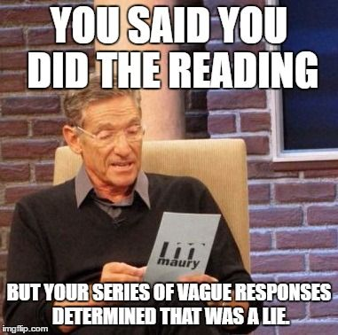
Email: Rachel.Lynch@k12.sd.us
Website: https://mslynchleola.weebly.com/
School Mission Statement:
All students will have equal access to an excellent educational program and be educated to their greatest potential. They will meet high academic standards through school interventions, and family involvement.
School Philosophy:
Each child, regardless of race, color, or creed, should have the opportunity for an equal education that will help him/her become what he/she is capable of becoming. In the education process the child should be considered as the prime objective. The education process should pick up the child where he/she is and work from there. We should give each child the opportunity and direction into many phases of the curriculum so that they can find themselves from a broad selection of possible interests. Education should prepare our children to be college/career ready. In order to do this, the individual will have to have a broad background and an understanding of many types of situations. It is therefore the responsibility of the school to provide a balanced curriculum, which offers opportunities for each child to gain this knowledge and experience. In the education process there should be enough freedom allotted so the student does not feel that he/she is regimented to the degree that will stifle his/her freedom of thought. It is necessary for the student to learn self-discipline as well as confidence and self-respect to cope with a changing environment.
Course Description:
This course is designed to prepare students for higher level ELA classes. Students will gain a better understanding of grammar, writing, and literature. Furthermore, they will learn how to apply all three to the “real world”.
Classroom Expectations:
- Be on time to class and stay for the full 50-minute period.
- Respect your teacher, classmates, and classroom.
- Give 110% every class.
- No eating/drinking/cellphones/iPods in the classroom.
- Any other rules decided upon the class (available on weebly).

Online Learning
- If you are learning online, you must be available to Zoom at the scheduled class time. If you are not there, it will be counted as absent.
- Assignments are due at class time. Google Classroom does time stamp, so don’t try to sneak in a paper in the middle of class.
- While on Zoom, you will be muted. If asked a question, you’ll unmute and answer.
- No cellphone or game use during class Zooms unless discussed prior to class.

Homework:
Weekly schedules and assignments will be available at: https://mslynchleola.weebly.com/
All homework will be due the following day at the beginning of class unless specified. It is YOUR responsibility to have your homework completed and handed in to me. Every late assignment will automatically be docked -2 points, with an extra -1 point for every day it is late. For example: if you turn your assignments in three days late it will be a -4 on the assignment. Large projects and papers worth 100 points or more will follow a similar to dock, but it will be percentages. For example, if a paper is worth 100 points the same scenario would result in a grade of 96% or lower.
If an assignment is later more than a week late, detentions will be held until the assignment is made up.
If you are gone, it is your responsibility to make up any missing tests and/or assignments upon your return. An email of what we did in class will be sent, and it’s your job to watch the Weebly for any changes. If you do not complete the test/assignments within one week, you will begin to be docked as stated above.

Book Reports:
High School
During the 2nd, 3rd, and 4th quarters you will be required to present a book report. Book report sheets will be available to grab at any time. The book must fit your reading level. We will take a day where you have to present on the book for five minutes. This is a graded project.
AR Points:
Middle School
Throughout the semester, you will be working towards your AR point goal. You must meet the AR point goal by the designated date at the end of the Semester. You may take AR tests during Library time.

Plagiarism/Cheating/Academic Dishonesty:
Turning in old work is academic dishonesty. Using Sparknotes on your paper without citation is plagiarism. Copying another’s work is plagiarism. I have a 0 tolerance policy with plagiarism/cheating. First offence, you will be required to rewrite your paper/homework/project with late points being docked and come talk to me. Second offence, you will be required to meet with me and discuss the issue, and you will receive a 0 on the plagiarized materials, and an email may be sent out to your parents/guardians at this time. Third offence, you will be required to meet with the principal, your parents/guardians, and me.

Google Classroom:
All work that is done on the computer must be handed in through Google Classroom. We will be using Google Docs and Google Slides in replacement of Word programs. If your assignment is not handed into Google Classroom, it will be counted as late
__________________________________________________________
General Information:
I want nothing more than for you to succeed in this class and to grow a love for ELA. If you are having any problems at all, please do not hesitate to talk to me. If you are having any troubles with the class, come to me immediately, and I can work with you individually and come up with a plan. Do not wait until the end of the quarter or semester to come to me, it may be too late.

Please check and sign below. Return to me by: August 23rd 2018

______________ I have read the information and I fully understand what I am expected to do in class.

Student Signature: ________________________________________

Parent/Guardian Signature: _________________________________

